How to complete a 2Do task on Purple Mash

- Log onto Purple Mash using the login given to your child www.purplemash.com/sch/kingspark
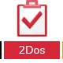
- Click on the ‘2Dos’ button on top left-hand corner of the screen.

- A list of the tasks assigned to your child are here. There will be a new English, maths and topic task every day.
- Click on the ‘start’ button to begin the task

- First there will be instructions on how to complete the task

- When you have finished the task, you must click to save and hand it in otherwise your teacher will not be able to see you have completed it and they will not be able to give you feedback.
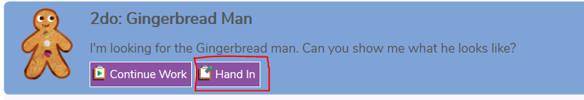

- When you save the task, you will often have a box to make a comment in, use this to tell the teacher if you found the task easy or hard or to ask any questions you may have.
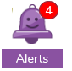
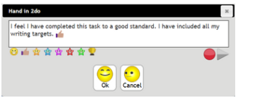

- You will get an alert when your teacher has responded and you will be able to see their comment. It will also tell you if your teacher has asked you to go back and redo the task.

- Any questions please email kpa@kingspark-academy.co.uk and we endeavour to answer them.

