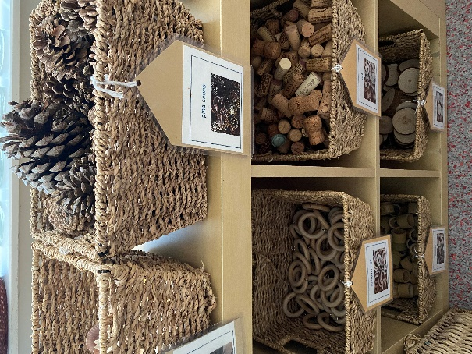

Autumn 1 - Welcome to Reception

The reception team have been so impressed with how well the children have settled into KPA. We have been learning all about each other and discovering the classroom. To help the children gather their things at home time, please ensure that all jumpers are named. ‘All About Me’ boxes will be shared in school over the next few weeks. We would also like to keep a family photo in school.

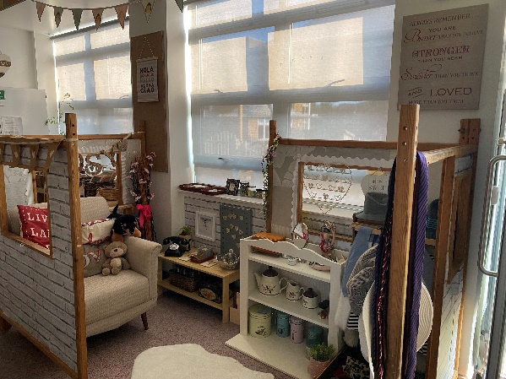

The classroom environments have been created using authentic resources to spark their curiosity. We will then plan for the children based on their own interests and the observations we have made of the children.

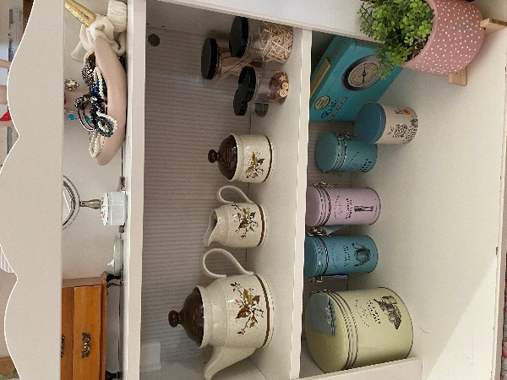

Loose parts allow for the children to use the resources how they want. With no pre-set idea of what the resources are for, the children generate their own play and the adults can support to extend their learning. At the beginning of each half term, we will send out a curriculum map sharing all the learning that has happened in the previous half term. Updates will be shared on the private Facebook group ‘KPA Reception 2021’ which can be found on the KPA Reception page.